MSWD Skilling In sem – 1

App.js Code:

import React from "react"; import './App.css';

import Button from '@material-ui/core/Button' import {

BrowserRouter as Router, Switch,

Route,

} from "react-router-dom";

function App() { return (

<Router>

<center>

<div>

<div className='bottons'>

<a href="/TajMahal"> <Button variant="contained" color="primar y"> 1st wonder </Button></a> {'\t'}

<a href="/GreatWallOfChina"><Button variant="contained" color= "primary"> 2nd wonder </Button> </a>

<a href="/ChichenItza"><Button variant="contained" color="prim ary"> 3rd wonder </Button> </a>

<a href="/Petra"><Button variant="contained" color="primary"> 4thwonder </Button> </a>

<a href="/ChristTheReedemer"><Button variant="contained" color

="primary"> 5thwonder </Button> </a>

<a href="/Colosseum"><Button variant="contained" color="primar y"> 6thwonder </Button> </a>

\<a href="/MachuPicchu"><Button variant="contained" color="pri mary"> 7thwonder </Button> </a>

</div>

<Switch>

<Route path="/TajMahal">

<TajMahal />

</Route>

<Route path="/GreatWallOfChina">

<GreatWallOfChina />

</Route>

<Route path="/ChichenItza">

<ChichenItza />

</Route>

<Route path="/Petra">

<Petra />

</Route>

<Route path="/ChristTheReedemer">

<ChristTheReedemer />

</Route>

<Route path="/Colosseum">

<Colosseum />

</Route>

<Route path="/MachuPicchu">

<MachuPicchu />

</Route>

</Switch>

</div>

</center>

</Router>

);

}

function TajMahal() { return (

<div className='head'>

<h2 className='dep' >Taj Mahal-India</h2>

<center> <img src="TajMahal.jpg" alt="Avatar"></img> </center>

<h3>description:</h3>

<p>

This mausoleum complex in Agra, India, is regarded as one of t he world’s most iconic monuments and is perhaps the finest example o f Mughal architecture. It was built by Emperor Shah Jahān (reigned 1 628–

58) to honor his wife Mumtāz Maḥal (“Chosen One of the Palace”), who died in 1631 giving birth to their 14th child. It took about 22 yea rs and 20,000 workers to construct the complex, which includes an im mense garden with a reflecting pool. The mausoleum is made of white marble that features semiprecious stones in geometric and floral pat terns. Its majestic central dome is surrounded by four smaller domes

. According to some reports, Shah Jahān wished to have his own mauso leum made out of black marble. However, he was deposed by one of his sons before any work began.

</p>

</div>

);

}

function GreatWallOfChina() { return (

<div className='head'>

<h2 className='dep'>Graet Wall of China</h2>

<img src="GreatWall.jpg" alt="Avatar"></img>

<h3>description:</h3>

<p>

Great might be an understatement. One of the world’s largest b uilding-

construction projects, the Great Wall of China is widely thought to be about 5,500 miles (8,850 km) long; a disputed Chinese study, howe ver, claims the length is 13,170 miles (21,200 km). Work began in th e 7th century BCE and continued for two millennia. Although called a “wall,” the structure actually features two parallel walls for leng thy stretches. In addition, watchtowers and barracks dot the bulwark

. One not-so-

great thing about the wall, however, was its effectiveness. Although it was built to prevent invasions and raids, the wall largely faile d to provide actual security. Instead, scholars have noted that it s erved more as “political propaganda.”

</p>

</div>

);

}

function ChichenItza() { return (

<div className='head'>

<h2 className='dep'>Chichen Itza-Mexico</h2>

<img src="ChichenItza.jpg" alt="Avatar" ></img>

<h2>description:</h2>

<p>

Chichén Itzá is a Mayan city on the Yucatán Peninsula in Mexico, whi ch flourished in the 9th and 10th centuries CE. Under the Mayan trib e Itzá—who were strongly influenced by the Toltecs—

a number of important monuments and temples were built. Among the mo st notable is the stepped pyramid El Castillo (“The Castle”), which rises 79 feet (24 meters) above the Main Plaza. A testament to the M ayans’ astronomical abilities, the structure features a total of 365 steps, the number of days in the solar year. During the spring and

autumnal equinoxes, the setting sun casts shadows on the pyramid tha t give the appearance of a serpent slithering down the north stairwa y; at the base is a stone snake head. Life there was not all work an d science, however.

</p>

</div>

);

}

function Petra() { return (

<div className='head'>

<h2 className='dep'>Petra</h2>

<img src="Petra.jpg" alt="avatar"></img>

<h3>description:</h3>

<p>

The ancient city of Petra, Jordan, is located in a remote vall ey, nestled among sandstone mountains and cliffs. It was purported t o be one of the places where Moses struck a rock and water gushed fo rth. Later the Nabataeans, an Arab tribe, made it their capital, and during this time it flourished, becoming an important trade center, especially for spices. Noted carvers, the Nabataeans chiseled dwell ings, temples, and tombs into the sandstone, which changed color wit h the shifting sun. In addition, they constructed a water system tha t allowed for lush gardens and farming. At its height, Petra reporte dly had a population of 30,000. The city began to decline, however, as trade routes shifted

</p>

</div>

);

}

function Colosseum() { return (

<div className='head'>

<h2 className='dep'>Colosseum</h2>

<img src="Colosseum.jpg" alt="avatar"></img>

<h3>description:</h3>

<p>

The Colosseum in Rome was built in the first century by orde r of the Emperor Vespasian. A feat of engineering, the amphitheater measures 620 by 513 feet (189 by 156 meters) and features a complex system of vaults. It was capable of holding 50,000 spectators, who w atched a variety of events. Perhaps most notable were gladiator figh ts, though men battling animals was also common. In addition, water was sometimes pumped into the Colosseum for mock naval engagements. However, the belief that Christians were martyred there—

namely, by being thrown to lions—

is debated. According to some estimates, about 500,000 people died i n the Colosseum. Additionally, so many animals were captured and the n killed there that certain species reportedly became extinct.

</p>

</div>

);

}

function ChristTheReedemer() { return (

<div className='head'>

<h2 className='dep'>Christ the Redeemer</h2>

<img src="ChristTheReedemer.jpg" alt="avatar"></img>

<h3>description:</h3>

<p>

Christ the Redeemer, a colossal statue of Jesus, stands atop Mount Corcovado in Rio de Janeiro. Its origins date to just after W orld War I, when some Brazilians feared a “tide of godlessness.” The y proposed a statue, which was ultimately designed by Heitor da Silv a Costa, Carlos Oswald, and Paul Landowski. Construction began in 19

26 and was completed five years later. The resulting monument stands

98 feet (30 meters) tall—

not including its base, which is about 26 feet (8 meters) high—

and its outstretched arms span 92 feet (28 meters). It is the larges t Art Deco sculpture in the world. Christ the Redeemer is made of re inforced concrete and is covered in approximately six million tiles. Somewhat disconcertingly, the statue has often been struck by light ning, and in 2014 the tip of Jesus’s right thumb was damaged during a storm.

</p>

</div>

);

}

function MachuPicchu() { return (

<div className='head'>

<h2 className='dep'>Machu Picchu</h2>

<img src="MachuPichu.jpg" alt="avatar"></img>

<h3>description:</h3>

<p>

Machu Picchu is a 15th-

century Inca citadel located in the Eastern Cordillera of southern P eru on a 2,430-

meter (7,970 ft) mountain ridge.[2][3] It is located in the Machupic chu District within Urubamba Province[4] above the Sacred Valley, wh ich is 80 kilometers (50 mi) northwest of Cuzco. The Urubamba River flows past it, cutting through the Cordillera and creating a canyon with a tropical mountain climate.[5].

</p>

</div>

);

}

export default App;

**OUTPUT:**

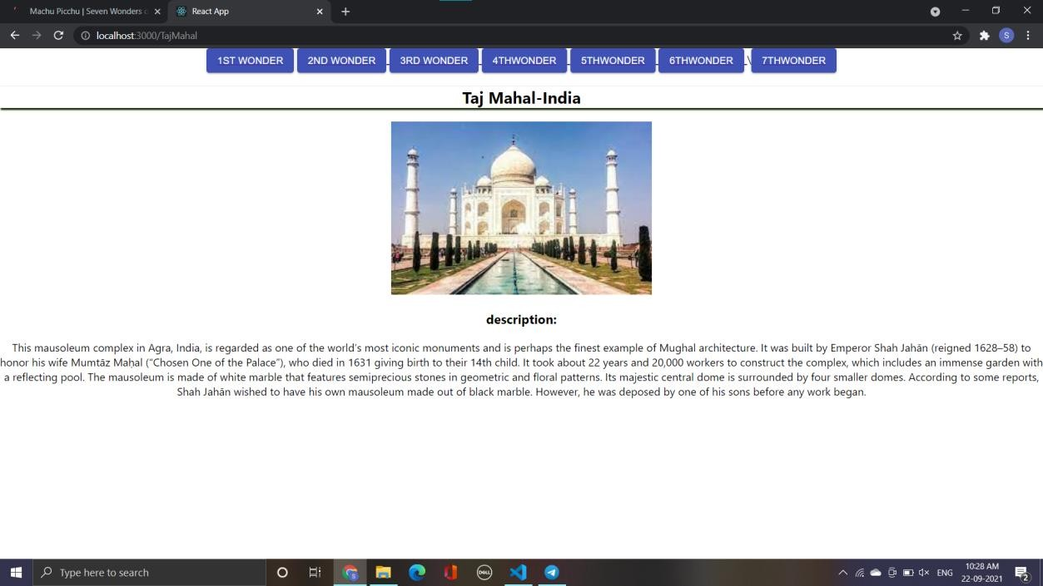

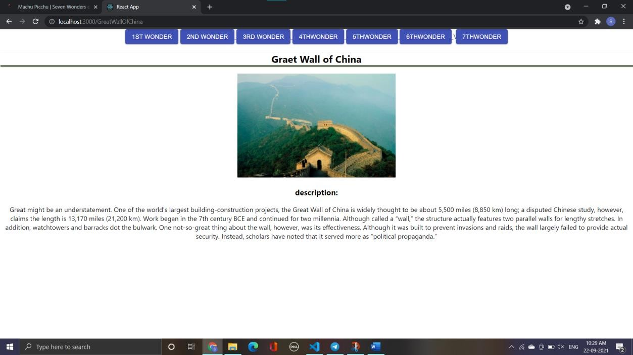



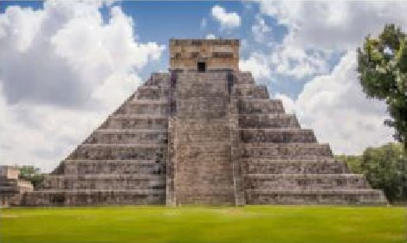 **chichen ltza-Mexico**

description:



sIru‹ture features a tool of 365 s **reps,** the numbei of days in the sol ar year. Do rl ng the spring and autum na1 eouinoxee che se c nd sun casu endows on the pyramid I hat giye be ap pear ance of a Serpent s lizhering



Petra

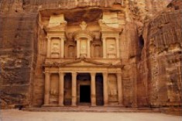

The ancient oil of tetra, Jordan, is located in a remote valley. nestled among ear+dsrone mountains and cliffs It was purported to be one of the places where Moses struck a rock and water gushed forth. Later the

Nabseean,znAreblfibe,made1hér‹apal,andduingfi+fmek9oui›hM,be‹omip* mpm«va‹hzene,epe‹Wl1or ires.N oied‹ awem theNsbaaean›‹:h+eeddwe LinW, ampes, a tombMno

the sandstor+e, which changed color w+Th the shif-tlng surj. In addition, they construcmd a waer System that allowed for lush gardens and farming. Ac in height Petra reportedly had a population of 30,0o0. ”he c›g





Christ the Redeemer

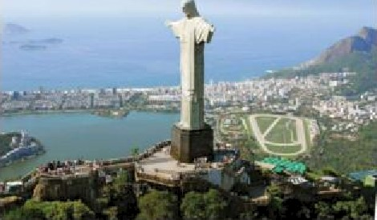



‹overedln approximaelysi milliontiles. 5omewñatdu<on‹eni gly thestaiue fiasoRen been›ti‹kbylgt‹nng,andln207gihe WpoC es ’srighiihumbwasdamaged dunngasio m.





Colosseum

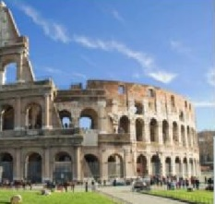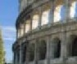

The C olosseum 4n Rome was builc in the fi‹st century by ordei of the Empe or vespaslan. A feat of eng‹reei ing, The amphitheatei measu es 620 by 513 feec (189 by 156 meters } and features a complex system of vaults It was capable of holding 50.000 spectators. who watched a variety of events Perhaps most notable were gJadiator fights. though men battling an‹rriaIs was also common. in add tion, water was sometimes gumped into

the c alas seum foi mock naval engagements However, the belief that Chi istrans were ma tiled the namely. by be‹ng thrown to hone s debated According to some est+mates, about s00,000 people died in the

Colosseum. Additionally, so many ams ale are ‹aptured and the‹J killed there that certain spec les reportedly became en met.





Machu Picchu

